**Optimization of the Number of Conveyors and Motors Used in the AmudCube**

* **Introduction**

Optimizing the number of conveyors and motors used in a production system is essential to improve energy efficiency, reduce costs, and maximize overall performance. This study aims to analyze the functioning of each conveyor and propose solutions to minimize the number of motors while ensuring optimal functioning.

* **Description of the Conveyor System**

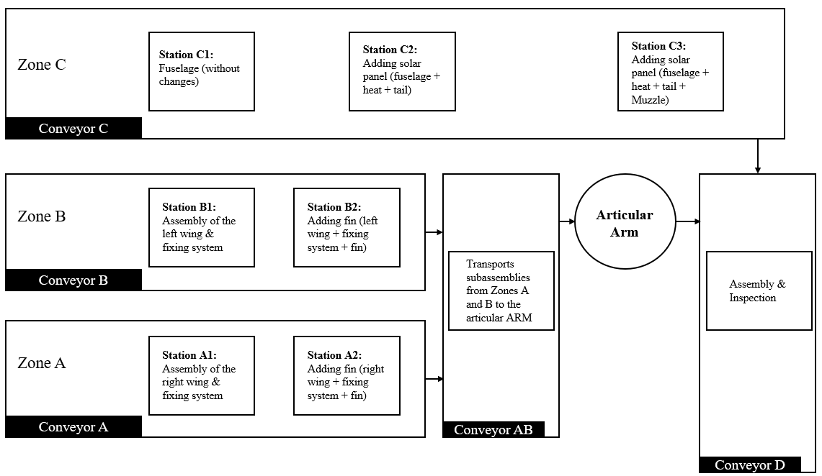 As part of the AmudCube project, the integration of an automated conveyor system plays a key role in optimizing the production flow and improving the efficiency of the assembly process. This network of conveyors transports subassemblies through different production areas, ensuring smooth transitions between each stage. Through synchronized communication between the conveyors and the articulated arm, each component is moved with precision, from the start of the production line to the final inspection. The addition of Conveyor D, dedicated to assembly and inspection, marks a critical step in ensuring the quality and compliance of the final product before its approval.

**Figure 1: Description of the Conveyor System**

* **Conveyor A**

**+ Role:** Transports the subassemblies from Zone A.

**+ Process:**

* Start: Station A1 assembles the right wing and the fastening system.
* Next,Station A2 adds the fin to complete the right wing.
* Finally, the subassembly is transferred to Conveyor AB.

**+ Communication:**

* Conveyor A is synchronized with the output of Station A2 to ensure that the finished parts are correctly moved.
* It transfers the assemblies to Conveyor AB for integration with the elements of Zone B.
* **Conveyor B**

+ **Role**: Transports the subassemblies from Zone B.

+ **Process**:

* Start: Station B1 assembles the left wing and the fastening system.
* Next, Station B2 adds the fin to complete the left wing.
* Finally, the subassembly is transferred to Conveyor AB.

+ **Communication**:

* Conveyor B is synchronized with the output of Station B2 to ensure smooth transfer of finished parts.
* It sends its subassemblies to Conveyor AB to be transported to the next stage.
* **Conveyor AB**

+ **Role**: Ensures the transportation of subassemblies from Zones A and B to the Articulated Arm.

+ **Process**:

* Receives the subassemblies from Conveyors A and B.
* Combines the right and left wings, ready for integration with the fuselage.
* Transfers these subassemblies to the Articulated Arm for final assembly.

+ **Communication**:

* It ensures the convergence of production flows by merging the parts from Zone A and Zone B.
* It is synchronized with the Articulated Arm to ensure that the parts are ready before the transfer.
* **Conveyor C**

+ **Role**: Transports the fuselage throughout the manufacturing process.

+ **Process**:

* Station C1 prepares the fuselage without modifications.
* Station C2 adds the solar panel, tail, and heating system.
* Station C3 finalizes the fuselage by adding the nose.
* The completed fuselage is transferred to the Articulated Arm.

+ **Communication**:

* It is synchronized with Stations C1, C2, and C3 to ensure the gradual transformation of the fuselage.
* It transfers the fuselage to the Articulated Arm, which will connect it with the wings.
* **Conveyor D**

+ **Role**: Transports the final assembly for inspection and validation.

+ **Process**:

* Receives the assembled structure from the Articulated Arm.
* Conducts quality tests and inspections.
* Verifies the conformity of the components and fastenings.
* Validates the assembly before shipping or final integration.

+ **Communication**:

* It is synchronized with the Articulated Arm to receive the finalized parts.
* It ensures that all previous steps of the process have been completed and checks that the assembly has been successfully performed before final approval.
* **Optimization Margin**

The use of three conveyors and three motors in Zone AB is not optimal in terms of cost and space. This configuration leads to higher energy consumption and takes up a significant volume in the production environment.  
A thorough analysis identified opportunities for optimization by reducing the number of conveyors and motors. After optimization, the chosen solution allows for:

* Reducing the number of conveyors from three to two, or even just one.
* Using a single motor instead of three.

This optimization leads to cost reduction (fewer motors, fewer components) and better space management by minimizing the system's footprint.

* **Needs and Constraints**

Before addressing the various optimization proposals, it is essential to fully understand the need. The goal is to design a system that can drive two conveyors with a single motor while ensuring their independent operation. Alternatively, the aim is to use a single conveyor capable of replacing both, while ensuring effective synchronization and optimal flow between the tasks performed by Conveyors A and B.

* **Optimization Objective**

The main objective is to design a more compact and efficient system by utilizing a mechanism that allows multiple conveyors to be driven by a single motor. This ensures better task synchronization while reducing energy consumption and manufacturing costs.

* **Proposed Optimizations**

In order to optimize the operation of the AmudCube prototype, four improvements have been identified to refine the conveyor system and the assembly of sub-assemblies. These optimizations focus on:

+ **Use of a Differential** Implementing a differential to improve torque distribution and optimize the movement of the conveyors. This solution helps manage load variations between the different conveyors, ensuring smoother movement and better efficiency.

+ **Use of Bevel Gear System** Employing a bevel gear system to ensure better transmission of movement and reduce energy losses. This system efficiently converts movement between perpendicular axes, reducing friction and mechanical losses, thus optimizing the conveyor's performance.

+ **Purchase of Pre-designed Conveyors** By opting for pre-designed and ready-to-use conveyors, we gain access to higher quality components, often tested for reliability. This solution also saves time on manufacturing and ensures quicker integration into the prototype, while reducing production costs.

+ **Use of a Dedicated Motor for Each Conveyor** Providing each conveyor with its own dedicated motor allows for better control over the speed and direction of each conveyor independently of the others. This helps optimize the overall system management, minimizes the risk of blockages or overloads, and allows for precise adjustments based on the specific needs of each conveyor.

The following table provides a comparative analysis of three conveyor system proposals:

**+ Use of a Differential (Proposal 1)**

**+ Use of a Single Conveyor in Zone A, B (Proposal 2)**

**+ Purchase of Conveyors Online (Proposal 3)**

Each proposal is assessed based on critical criteria, including **number of conveyors, motor requirements, implementation complexity, reliability, and cost**. The goal is to identify the most efficient and cost-effective solution while ensuring **functionality, ease of maintenance, and feasibility**.

|  |  |  |  |  |  |
| --- | --- | --- | --- | --- | --- |
| **Criteria** | **Use of a**  **Differential**  (Proposal 1) | **Use of a Single**  **Conveyor in**  **Zone A, B**  (Proposal 2) | **Purchase of**  **Conveyors Online**  (Proposal 3) | **Requirements** | **Approved Proposal** |
| Number of  Conveyors | 5 | 4 | 5 | Reduce the number of conveyors while maintaining functionality | **Proposal 2** |
| Number of  Motors  Required | 4 | 3 (with the use of a bevel gear system) | 0 (pre-installed motor in purchased conveyor) | Minimize motor usage while ensuring functionality | **Proposal 2**: However, when using a bevel gear system, if the motor ceases functioning, the conveyors in zones A, B, and AB will stop operating. |
| Implementation  Complexity | High | Medium | Low | Minimize implementation complexity | **Proposal 3** is the approved proposal as it is already assembled, unlike Proposal 1 and Proposal 2 that require assembly. |
| Reliability and  Maintenance | Good | Good | Poor | Ensure high reliability and ease of maintenance. | **Proposal 2**: Proposal 3 is poor because the compact conveyor may be difficult to fix if it malfunctions, while Proposal 1 has a  complex differential system. |
| Cost | Low | Low | High | Minimize cost while maintaining functionality. | **Proposal 1 & 2** are approved, as most components already exist or will be 3D printed. |

**Table 1: Comparison table**

* **Conclusion:**

After evaluating the different proposals, **Proposal 2** emerges as a strong choice due to its ability to minimize the number of conveyors and motors while maintaining functionality. However, it has a potential drawback: if the **single motor fails**, it will impact multiple conveyors. **Proposal 3** offers the simplest implementation but lacks reliability and ease of maintenance. In terms of cost, both **Proposals 1 and 2** are the most viable, as they utilize **existing or 3D-printed components**. The final decision will be made based on **prioritizing functionality, cost-effectiveness, and long-term reliability**.

* 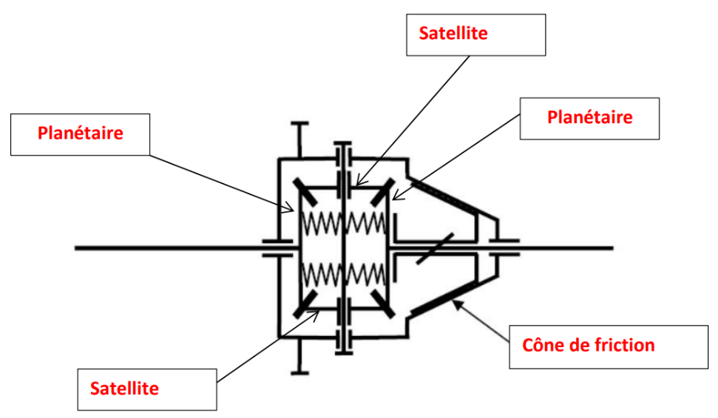**First Proposal: Use of a Differential**

**Figure 2 : Kinematic Diagram of the Differential**

**Figure 3 : Different Components of a Differential**

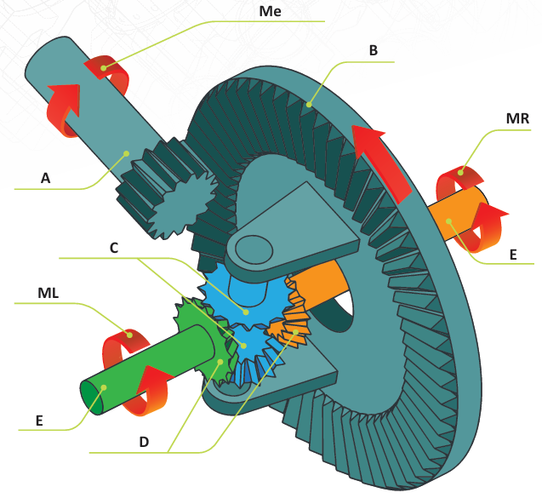

A first solution considered is to use a differential to distribute the motor power between conveyors A and B.

In this configuration:

+ The motor drives the drive pulley of the conveyor through a **pulley-belt system**.

+ The two **planetary gears** of the differential transmit the movement to conveyors A and B.

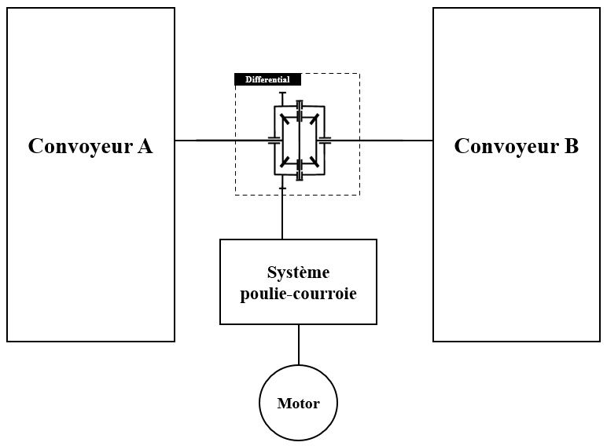

**Figure 4 : Use of the Differential**

* **Advantages of this Solution**

This approach initially seems promising, as it allows automatic distribution of power between the two conveyors based on the loads applied to each. It provides a balanced distribution of torque and optimizes energy use.

* **Limitations of this Solution**

However, after further analysis, we identified a major limitation: It is impossible to stop one conveyor while allowing the other to operate normally without adding an additional element, such as an electromagnetic clutch. However, this would increase the size, which contradicts our goal of optimizing space.

* **Verification of Motor Performance for Driving Both Conveyors**

Before adopting the solution of driving both conveyors with a single stepper motor, a theoretical study is necessary to verify if the selected motor can provide the required torque to ensure the proper functioning of the system.  
 In this analysis, we will neglect mechanical losses (friction, gear play, belt elasticity, etc.) and focus solely on the distribution of torque within the system.

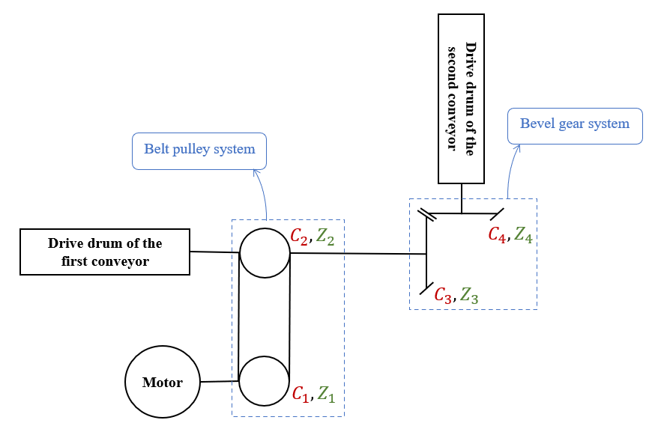

**Figure 5: Systems Used in Motion Transmission**

* **First System: Pulley-Belt System**

The transmission ratio between pulleys 1 and 2 is expressed as follows:

$$r_{1→2}= \frac{Z_{2}}{Z_{1}}=\frac{C_{1}}{C_{2}}$$

Where :

+  : The number of teeth on pulley 1 (driving pulley)

+  : The number of teeth on pulley 2 (driven pulley)

+  : Torque on pulley 1 in mN.m (**Data obtained from the motor’s torque curve**)

+ : Torque on pulley 2 in mN.m

N.A:

$$r_{1→2}= \frac{C_{1}}{C_{2}}=1 ⇒ C_{1}=C_{2}=100 mN.m$$

* **Second system: Bevel gear system**

The transmission ratio between gears 3 and 4 is expressed as follows:

$$r_{3→4}= \frac{Z_{4}}{Z_{3}}=\frac{C_{3}}{C_{4}}$$

Where :

+  : Number of teeth on gear 3 (driving gear)

+  : Number of teeth on gear 4 (driven gear)

+  : Torque on gear 3 in N.cm (taken from the torque curve of the motor)

+ : Torque on gear 4 in mN.m

N.A :

$$r_{3→4}= \frac{C_{3}}{C_{4}}=1 ⇒ C_{3}=C_{4}=100 mN.m$$

After a theoretical analysis of the subsystem consisting of two conveyors, we demonstrated that the torque required for driving them is CCC, the same torque required to operate a single conveyor. This conclusion arises from the fact that the motion transmission between the two conveyors occurs with a 1:1 transmission ratio, without any torque amplification, and by neglecting mechanical losses. A comparison between this torque CCC and the nominal torque provided by the motor was then made:

$$C_{motor}=100 mN.m>> C_{needed}=1.36 mN.m$$

It can be concluded that the motor has sufficient power margin to drive the entire subsystem, thus ensuring its proper functioning without any risk of overload.

* **Second Proposal: Use of a Single Conveyor**

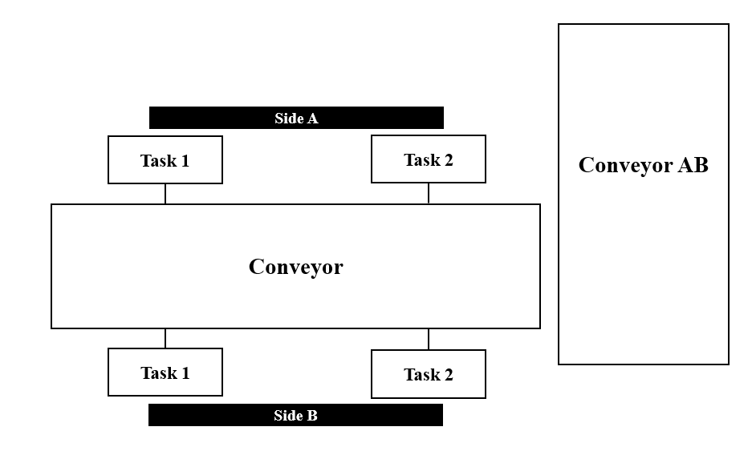 To overcome the limitations of the first solution, a more efficient alternative is to replace conveyors A and B with a single conveyor capable of performing all the tasks previously distributed across the two separate conveyors.

**Figure 6: Use of a Single Conveyor**

* **Constraints**

With a single conveyor, the main challenge is to ensure the smooth flow of tasks that were previously handled separately by conveyors A and B. It is essential to organize and synchronize operations to prevent disruptions and ensure a seamless transition between the various stages of the process.

An additional constraint arises with the use of a single stepper motor to drive both conveyors. The motor is positioned beneath the main conveyor to optimize space. The motion transmission system must drive both the main conveyor and the second conveyor (responsible for collecting products) while considering the perpendicular orientation of their rotational axes. Therefore, it is necessary to design a transmission system that ensures efficient synchronization and an even distribution of the motor torque across both conveyors.

* **Advantages of this Solution**

With a single conveyor, it becomes possible to optimize the use of machines and ensure better continuity of production in case of a breakdown. Since both sides (A and B) perform the same tasks (Task 1 on side A is identical to Task 1 on side B, and so on), a product waiting to be processed can be handled by any available machine.

This offers a crucial advantage in case of a machine failure:  
If a machine on one side breaks down, the product is not stuck. It simply waits for the equivalent machine on the other side to become available for processing.  
Thus, production continues without major interruptions, improving system flexibility and reducing production losses due to technical downtimes.

* **Comparison with the Previous Solution**

Unlike the differential solution, where a failure on one side forces the entire process to stop (since it is impossible to drive a single conveyor independently), using a single conveyor allows for smarter resource management and ensures continuity of production.

* **Use of a Single Motor to Drive Both Conveyors**

One of the main technical challenges of this optimization is using a single stepper motor to drive both conveyors simultaneously. This approach reduces energy consumption, minimizes space requirements, and simplifies the system's control.

The motor is placed beneath the main conveyor and drives a pulley-belt system connected to the drive drum of the first conveyor. Since the axis of rotation of the second conveyor's drum is perpendicular to the first one, a system of bevel gears is used to efficiently transmit the movement and synchronize the two conveyors.

* **Third Proposal: Purchase of Conveyors Online**

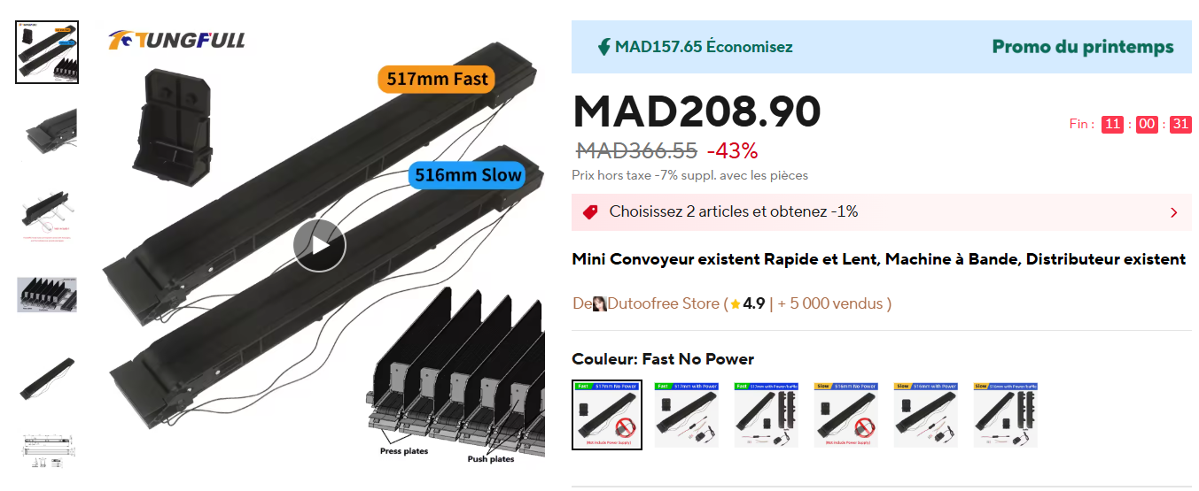 After conducting thorough research, we have identified several models of industrial conveyors available online at an affordable price, which aligns with our budget.

**Figure 7: Example of a Conveyor for Sale Online**

* **Advantages:**
* **Significant time savings** (no internal design or manufacturing required).
* **Guaranteed reliability** (products are tested and validated industrially).
* **Wide range** **of options** according to required technical specifications.
* **Reduced risks associated with design** (no assembly issues).
* **Disadvantages:**
* **Less customization** compared to a tailor-made design.
* **Dependence on suppliers** (delivery times, compatibility with the existing system).
* **Fourth Proposal: Use of a Motor for Each Conveyor**

Each conveyor in the system is independently powered by its own motor, without a differential or common mechanical transmission.

* **Advantages:**
* **Simplicity and Efficiency**: Each conveyor operates independently, allowing for precise control of speed and acceleration.
* **Easier Maintenance**: In case of failure, only one motor needs to be replaced, without affecting the other conveyors.
* **System Flexibility**: It is easy to modify the speed or direction of each conveyor as needed.
* **Better Load Management:** Each motor can be sized according to the specific load of the conveyor it powers.
* **Disadvantages:**
* **Higher Cost**: Requires the purchase of multiple motors, increasing the electrical component budget.
* **Higher Energy Consumption**: Multiple motors running simultaneously lead to increased energy consumption.